EVENING SERMON TEXT: Judges 4
__________________________________________________________________________________________________________________________________________________________________________________________________________________________________________________________________________________________________________________________________________________________________________________________________________________________________________________________________________________________________________________________________________________________________________________________________________________________________________________________________________________________________________________________________________________________________________________________________________________________________________________________________________________________________________________________________________________________________________________________________________________________________________________________________________________________________________________________________________________________________________________________________________________________________________________________________________________________________________________________________________________________________________________________________________________________________________________________________________________________________________________________________

Contact Details
Pastor Hennie van Niekerk
Cell: 076 320 0286 Office: 012 661 1830
Church Address
Postal: PO Box 2703 Physical:120 Maraboe Ave. The Reed Rooihuiskraal 0158 0154

http://www.emmausbc.org

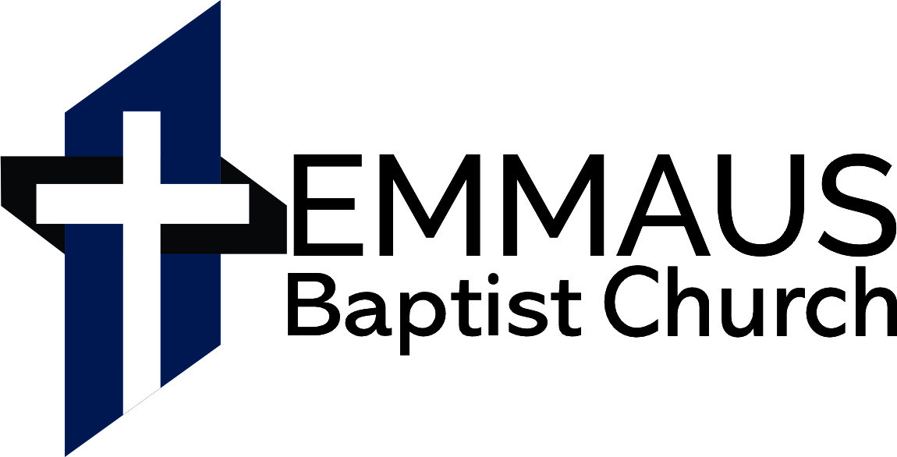
Ps 111:1 ​Praise the LORD! I will give thanks to the LORD with my whole heart, in the company of the upright, in the congregation.
4 July 2021
Morning Service 10:00
Text: 1 Corinthians 2:1-5
Evening Service 17:30
Text: Judges 4

WEEKLY PROGRAMME

Sunday 11 July
10h00 Morning Worship
17h30 Evening Worship
https://www.emmausbc.org/live-services
Wednesday 30 June
No Bible study
Saturday 3 July
7h00 Prayer meeting

PRAYER ITEMS
- Thank the Lord for his faithfulness. He works all thing together for the good of his people (Rom 8:28-39)

1Tim 2:1-2 First of all, then, I urge that supplications, prayers, intercessions, and thanksgivings be made for all people, for kings and all who are in high positions, that we may lead a peaceful and quiet life, godly and dignified in every way.
- Pray for all earthly authorities as God commands us, and for his people to submit to and trust the Lord in all things.
- Pray for the local church, and our obedience to the Lord in all things. Especially our service among one another.
- Pray for the men and the women, for families and children. The biblical family is under many threats daily.
- Pray that the Lord would raise up men to serve as elders among us. Pray that these men would serve in the church, that they be recognized and confirmed in the congregation.
- Missionaries: Pray for God’s word to reach all men, and for God to provide for every need of His people according to His wisdom. Especially pray for…
- Barry & Julia Funnell (Children: Lisa, Timothy & Daniel) - Word for the world- UK– translating the Bible.
- Jako & Amber (Jakob & Jeremiah). Mission of Love Orphanage in Kalomo, Zambia.

If there are any specific prayer requests from anyone in the church please send it to the Pastor to put into the Newsletter

Read through the Bible weekly reading
Monday (5 July):
2 Chronicles 6-10, Ps. 30
Tuesday (6 July):
2 Chronicles 11-16
Wednesday (7 July):
2 Chronicles 20-21, Prov. 14
Thursday (8 July):
2 Chronicles 22-26, Ps. 121
Friday (9 July):
2 Chron. 27-30, Ps. 122-123
Saturday (10 July):
2 Chronicles 31-36

Birthdays and Anniversaries
None

Q. 59. Which is the third commandment?
A. The third commandment is, "Thou shalt not take the name of the Lord thy God in vain: for the Lord will not hold him guiltless that takes his name in vain."

(Exodus 20:7)

Church Banking details:
Bank: First National.
Branch: The Lake
Account Name: The Emmaus Baptist Church
Cheque Account No. 545 0706 1403

MORNING SERMON TEXT: 1 Corinthians 2:1-5

