EVENING SERMON TEXT: Judges 3:8-11
God sold Israel ino the hand of the enemies. Israel was comfortable with the Canaanites and walked in closer fellowship with them, that ultimately became Idolatry. Then Israel cried our to the Lord, beginning a cycle of reversal, considered under three headings. Repentance, Rescue and Rest.
Repentance: Judg 3:9 But when the people of Israel cried out to the LORD… Israel cried out to the Lord, echoeing the cry that came to the Lord because of the slavery of Israel in Egypt (Ex 1). The Lord had promised destruction would surely follow them if they forsake the Lord their God. Israel cannot expect God to save them, Israel cannot presume that God will save them, but God is rich in mercy!
Rescue: …the LORD raised up a deliverer for the people of Israel, who saved them, Othniel the son of Kenaz, Caleb's younger brother.Judg 3:10 The Spirit of the LORD was upon him, and he judged Israel. He went out to war, and the LORD gave Cushan-rishathaim king of Mesopotamia into his hand. And his hand prevailed over Cushan-rishathaim.
Othniel the first judge to suceed Joshua, was a man that served under Joshua and Caleb. God raised him up to be a deliverer to Israel. Like Moses before and Jushua, Othniel the deliverer was empowerd by the Holy Spirit for this work. God calls and enables his servants to do their work.
Rest: Judg 3:11 So the land had rest forty years. Then Othniel the son of Kenaz died. God gives rest to the land. He had granted Israel relief through the hand of Othniel, his servant.

Contact Details
Pastor Hennie van Niekerk
Cell: 076 320 0286 Office: 012 661 1830
Church Address
Postal: PO Box 2703 Physical:120 Maraboe Ave. The Reed Rooihuiskraal 0158 0154

http://www.emmausbc.org

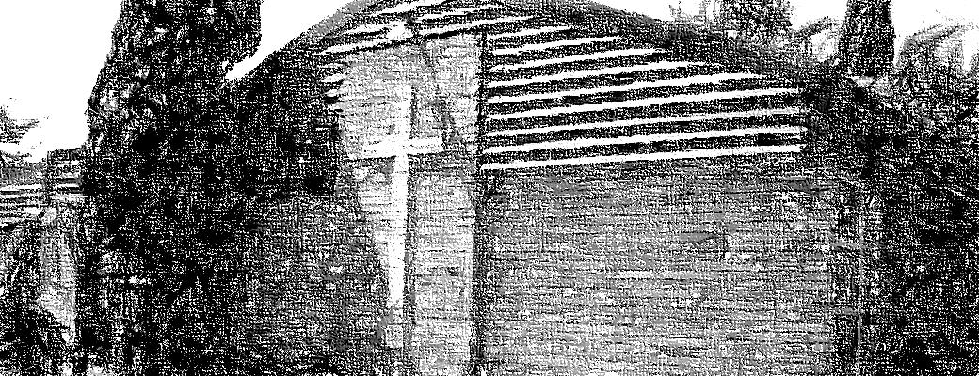
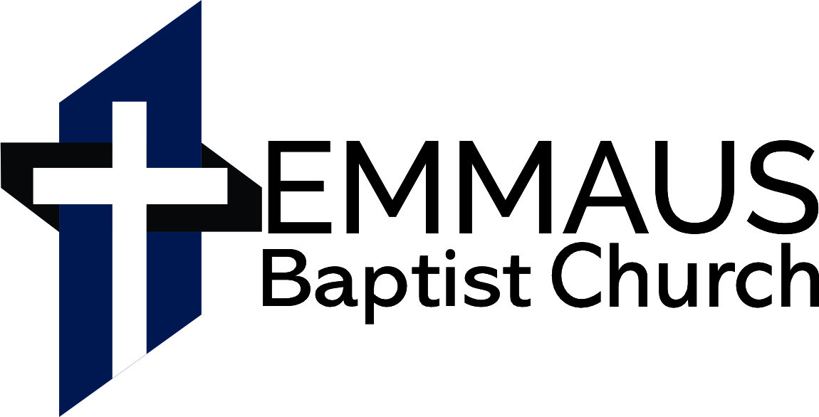
Ps 111:1 ​Praise the LORD! I will give thanks to the LORD with my whole heart, in the company of the upright, in the congregation.
6 June 2021
Morning Service 10:00
Sermon: 1 Corinthians 1:26-30
Evening Service 17:30
Sermon: Judges 3:8-11

WEEKLY PROGRAMME

Sunday 13 June
9h00 Adult Bible Class
10h00 Morning Worship
17h30 Evening Worship
https://www.emmausbc.org/live-services
Wednesday 9 June
18h00 Fellowship 18h30 Bible Study
Saturday 5 June
7h00 Prayer meeting

PRAYER ITEMS
- Thank the Lord for his faithfulness. He works all thing together for the good of his people (Rom 8:28-39)

1Tim 2:1-2 First of all, then, I urge that supplications, prayers, intercessions, and thanksgivings be made for all people, for kings and all who are in high positions, that we may lead a peaceful and quiet life, godly and dignified in every way.
- Pray for all earthly authorities as God commands us, and for his people to submit to and trust the Lord in all things.
- Pray for the local church, and our obedience to the Lord in all things. Especially our service among one another.
- Pray for the men and the women, for families and children. The biblical family is under many threats daily.
- Pray that the Lord would raise up men to serve as elders among us. Pray that these men would serve in the church, that they be recognized and confirmed in the congregation.
- Missionaries: Pray for God’s word to reach all men, and for God to provide for every need of His people according to His wisdom. Especially pray for…
- Barry & Julia Funnell (Children: Lisa, Timothy & Daniel) - Word for the world- UK– translating the Bible.
- Jako & Amber (Jakob & Jeremiah). Mission of Love Orphanage in Kalomo, Zambia.

If there are any specific prayer requests from anyone in the church please send it to the Pastor to put into the Newsletter

Read through the Bible weekly reading
Monday (7 June):
Hosea 8-14
Tuesday (8 June):
Psalm 22-24, Prov. 9
Wednesday (9 June):
Obadiah 1
Thursday (10 June):
Amos 1-5, Psalm 25
Friday (11 June):
Amos 6-10, Prov. 10
Saturday (12 June):
Zeph. 1-3, Ps 9-11, Prov. 11

Birthdays and Anniversaries
8 Balti Erasmus

Q. 56. What is required in the second commandment?
A. The second commandment requires the receiving, observing, and keeping pure and entire, all such religious worship and ordinances, as God has appointed in His Word.

(Deut. 32:46; Matt. 28:20; Deut. 12:32)

Church Banking details:
Bank: First National.
Branch: The Lake
Account Name: The Emmaus Baptist Church
Cheque Account No. 545 0706 1403

MORNING SERMON TEXT: 1 Corinthians 1:26-30
The Church in Christ: the Power and Wisdom of God
Paul and all his fellow workers preach the Gospel. The Content of this gospel is Christ as the crucified Son of God. The content is scandalous to the Jews. The Gospel is foolish to the Greeks. They preach the true, (undiluted and pure) content of the Gospel of Christ.
Paul turns to the Corinthians and exhorts them to: Consider their calling. “Remember the first time you heard the gospel of the crucified Christ.” “Think of what you were before you became a Christian.”
Paul reminds them that they were of the lowly people according to the flesh. They were not among the wise, the strong and the noble. The Christians who boast and quarrel with one another are reminded of their standing in the world. “Think of what you were.” “You were outcasts, lowly folk and foolish.” When the call of God reached your ears you were of no account in the world. Then he turns their attention from themselves, to considering God. He starts with a wonderful statement: “But God…”
Three times Paul echoes: “God chose…” God did not choose them because they were wise, strong and noble. God deliberately chooses what the world despises. God chooses what the world would reject.
You see God did not choose the Corinthian Christians for their excellent wisdom, powerful strength or the greatness of their family connections. Likewise, God does not choose you for your strength, but for your weakness.
Do you think that you are called to be well dressed, well behaved and nice? God has chosen the Christian to shame the worldly wisdom, power and nobility! God has not called you to sit in a corner and wait for better days. God chose in order to accomplish something through you. How does God accomplish things through us? How does God display his glory through his servants?

